

Name
Talha Abdullah Bangyal
Roll Number
SU92-BAIFM-F25-002
Section
BAI-5B
Subject
Computer Network (Lab)
Submitted To
Yusra Shafique

Table of Contents
Task 1 2
Download cisco Packet Tracer and Paste screenshot of downloaded tool. 2
Task 2 3
What is cisco packet tracer? 3
Why do we use it? 3
Task 3 3
What is the difference between all the routers, and when to use them? 3
Task 4 5
What is the difference between all the switches, and when to use Them? 5
Task 5 6
What is the difference between all the connection wires, and when to use them? 6

Note: Don’t copy paste. Submit your task at given time.

Task 1

Download cisco Packet Tracer and Paste screenshot of downloaded tool.
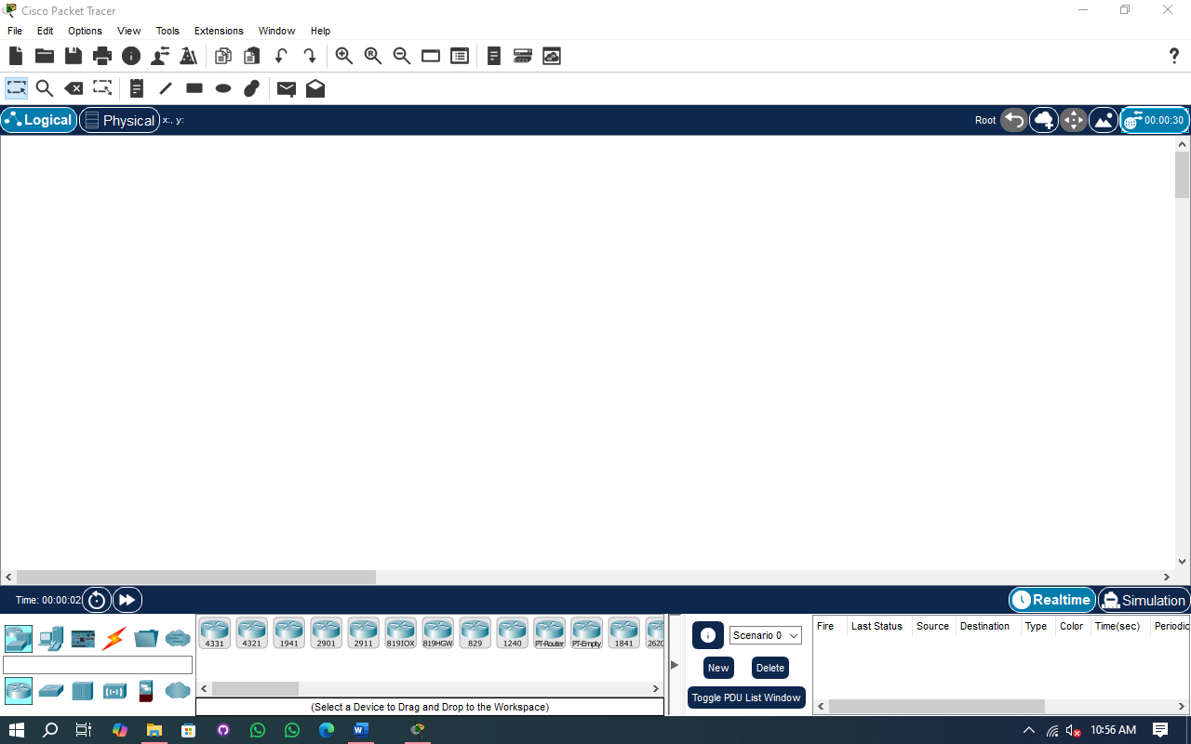
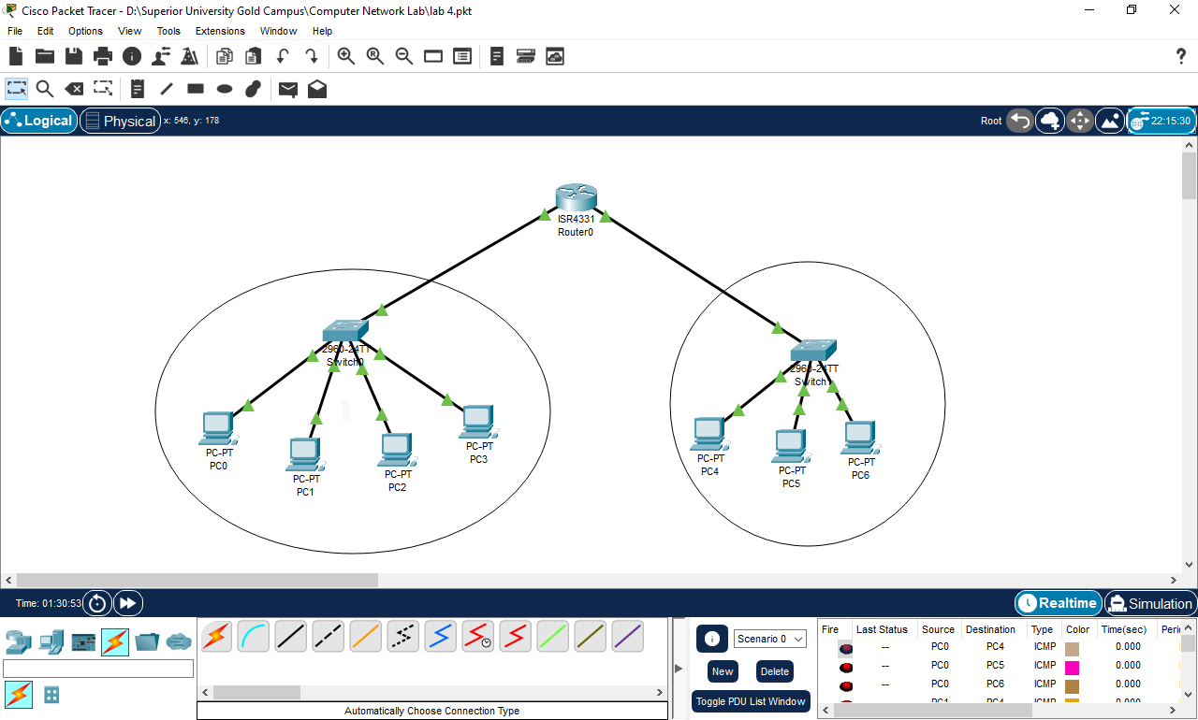

Task 2

What is cisco packet tracer?
Cisco Packet Tracer is a cross-platform network simulation tool created by Cisco Systems that lets users build and visualize virtual network topologies using drag‑and‑drop. It also emulates a Cisco-like command-line interface (CLI) to configure routers, switches, and other devices.

Why do we use it?
Packet Tracer offers a cost‑effective, cross‑platform virtual lab that enables safe, hands‑on practice with core networking concepts like VLANs, routing, and DHCP via intuitive visual and CLI tools; it’s perfect for CCNA/CCNP prep, network design testing, and dynamic packet flow visualization, all without needing real hardware

Task 3

What is the difference between all the routers, and when to use them?
Cisco offers a range of routers to meet various network needs, including those for enterprise, branch, industrial, and mobile environments. Each model offers specific features, such as speed, modularity, ruggedness, or wireless support. This variety ensures businesses can choose the right router based on performance, location, and functionality requirements for efficient network operations.
- Cisco 4331 / 4321
These are part of the ISR 4000 series, designed for medium to large branch offices. They offer modularity, high performance, advanced security, and support for services like SD-WAN, VPN, and voice. Ideal for modern enterprise networks.
- Cisco 1941 / 2901 / 2911
These are older ISR G2 models for small to medium branch deployments. They support modular interfaces, security features, and voice/video services. Still used in labs or legacy systems, but largely replaced by the 4000 series.
- Cisco 8191OX / 819HGW
Compact, hardened routers for mobile or harsh environments. Common in transportation, outdoor kiosks, and field deployments. Include support for LTE, GPS, and multiple WAN options, with a rugged form factor.
- Cisco 829
Like the 819 series but with additional features for mobile and industrial use. Supports high-speed LTE, GPS, and rugged design, making it ideal for transportation, public safety, or remote IoT deployments.
- Cisco 1240
Often confused with a router, the 1240 is a wireless access point used for enterprise Wi-Fi coverage. It doesn’t handle routing but connects wireless clients to the wired network.
- PT-Router / PE-Empty
These are virtual routers used in Cisco Packet Tracer for simulation and learning purposes. PT-Router is a general-purpose router, while PE-Empty allows custom configurations. Not real hardware, but useful for practice.
- Cisco 1841
Designed for small branch offices, offering basic routing, VPN, and limited modularity. Now obsolete and mainly used for training or in very small networks with basic requirements.
- Cisco 2620XM
Part of the 2600 series, suitable for small office routing and basic WAN needs. Supports modular WAN/LAN interfaces. Obsolete and primarily used in labs or legacy environments.
- Cisco 2811
An older branch router with modular slots, voice support, and basic security features. Once popular in SMBs, but now outdated. Common in CCNA/CCNP labs and simulations.

Task 4

What is the difference between all the switches, and when to use Them?
Switches vary to meet different network needs, environments, and functionalities. Access switches connect end devices locally, industrial switches endure tough conditions, and Layer 3 switches manage routing to optimize network traffic.
- 2960 / 2950-24 / 2950T
These are fixed-access switches commonly used in small to medium networks to connect devices like computers and printers. The 2960 offers improved performance and security compared to the older 2950 models.
- 3560-24ps / 3650-24ps
Layer 3 switches that support routing and Power over Ethernet (PoE), powering devices such as IP phones and wireless access points. Suitable for larger networks needing integrated switching and routing.
- IE 2000
Industrial-grade switches designed for harsh environments like factories and outdoor locations, built to withstand extreme conditions and provide reliable connectivity.
- PT-Switch / PT-Empty / PT-Bridge
These are virtual devices in Cisco Packet Tracer. PT-Switch simulates a basic Layer 2 switch, PT-Empty is a placeholder, and PT-Bridge is used to connect different network segments in simulations.

Task 5

What is the difference between all the connection wires, and when to use them?
Cables vary depending on their purposes such as management, device connections, data transfer, or environmental needs. Choosing the right cable ensures proper communication, consistent signal quality, and optimal network performance based on distance, speed, and device compatibility.
- Console
Connects a computer to a device’s console port for configuration and troubleshooting.
- Copper Straight Through
Used to connect different device types, such as PCs to switches or routers.
- Copper Crossover
Connects similar devices directly, like switch-to-switch or PC-to-PC, without an intermediary device.
- Fiber
Provides high-speed, long-distance connections between switches or data centers, resistant to electrical interference.
- Phone
Connect traditional telephony equipment or PBX systems.
- Coaxial
An older type of cable used in legacy networks and broadband setups.
- Serial DCE / Serial DTE
Used for WAN connections; DCE devices supply clock signals, while DTE devices receive them.
- Octal
A multi-port serial cable connecting multiple serial interfaces at once.
- IoT Custom Cable
Specific to Packet Tracer, used for connecting Internet of Things devices in simulations.
- USB
Connects peripherals or provides device management access.

